Introduction:

The "Internet Quality and Speed Evaluation Tool" project aims to address a pressing need for individuals and organizations seeking reliable insights into their internet connectivity. This comprehensive tool will offer in-depth evaluations of critical aspects of internet performance, ranging from download/upload speeds to network responsiveness, jitter, and packet loss. Additionally, it will cater to the specific needs of property buyers, allowing them to assess the reliability and strength of internet services compared to the market average.

Identification of Problem:

In today's digital landscape, the significance of robust internet connectivity cannot be overstated. As individuals and businesses increasingly rely on seamless online operations, the need for a tool to assess internet quality has become paramount. This project comes in response to a pervasive issue where users face challenges in accurately gauging their internet performance, leading to uncertainties in decision-making processes, particularly evident in property purchases.

The advent of remote work, digital learning, and online business operations has intensified the demand for reliable, high-speed internet connections. Despite this, a common challenge persists: the lack of accessible, user-friendly tools that offer comprehensive insights into internet quality and speed. Property buyers, especially, face uncertainties when evaluating prospective locations due to limited access to detailed information regarding internet services in those areas.

This project aims to bridge this gap by offering a robust, user-centric tool that provides precise evaluations of internet speed and quality. By doing so, it empowers users with critical data necessary for informed decision-making in various contexts, particularly impacting property purchasing choices positively.

Research on Internet Speed Tests

Internet speed tests serve as crucial tools to measure the performance and quality of internet connections. Hence it was mandatory that I do my research before expediting this project hence I have gathered some of the top pieces of information that would make up the structural integrity of this project.

Test Metrics and Parameters:

Internet speed tests typically measure several parameters:

Download Speed: The rate at which data is transferred from the internet to a device.

Upload Speed: The rate at which data is transferred from a device to the internet.

Ping (Latency): The time taken for data to travel from a device to a server and back, indicating network responsiveness.

Jitter: Variation in ping over a period, revealing network stability.

(Appendix A: Explanation of Test Metrics)

Factors Affecting Test Results:

Several variables can impact the accuracy of speed test results:

Network Congestion: Higher traffic can temporarily reduce speeds.

Device Limitations: Older devices may not achieve maximum speeds.

Distance from Server: Proximity to the test server influences results.

Service Provider Throttling: Some providers limit speeds for certain activities.

(Appendix B: Influential Factors on Test Results)

Interpreting Test Results:

Understanding what constitutes good or poor speed test results is crucial. For instance:

Download Speeds: Minimum requirements for streaming, gaming, or downloading files.

Upload Speeds: Crucial for activities like video conferencing or file sharing.

Ping and Jitter: Essential for real-time applications like online gaming or video calls.

(Appendix C: Interpretation of Test Results)

Test History and Longitudinal Analysis:

Maintaining a history of speed test results allows for trend analysis and identification of patterns over time. It assists in:

Detecting Network Issues: Consistently slow speeds or frequent disruptions.

Comparing Service Providers: Evaluating different ISPs based on performance.

Verifying Service Quality: Confirming advertised speeds against actual performance.

(Appendix D: Importance of Test History)

Improving Internet Performance:

Insights from speed tests can guide actions to enhance internet performance:

Router Placement: Optimizing router positioning for better coverage.

Equipment Upgrades: Updating devices or routers to support higher speeds.

ISP Communication: Addressing issues or considering plan upgrades for better performance.

(Appendix E: Actions Based on Test Insights)

Objectives of the Project

2) User Need: Evaluate Internet Speed and Quality

Specific Objectives:

2.1Measure and display download speeds comprehensively.

2.2Measure and display upload speeds accurately.

2.3Measure and display network responsiveness (ping).

2.4Measure and display network stability (jitter).

2.5Measure and display packet loss.

3)User Need: Intuitive Interface for Speed Tests

Specific Objectives:

3.1Design a user-friendly interface for initiating speed tests.

3.2Ensure ease of interpretation for test results.

4)User Need: Performance Analysis and Interpretation

Specific Objectives:

4.1Interpret and present test results effectively for users.

4.2Provide comparisons against industry benchmarks for performance assessment.

4.3Define criteria for categorizing good versus poor internet performance.

5)User Need: Longitudinal Tracking of Internet Performance

Specific Objectives:

5.1Develop a system to store and track historical test results.

5.2Enable trend analysis to identify consistent network issues.

5.3Allow comparisons between different Internet Service Providers (ISPs) based on performance.

5.4User Need: Actionable Insights for Performance Improvement

Identification Of the Prospective Users:

The ideal users will be the general public for basic internet speed testing. Since it is based on the general knowledge it should be easy to use without requiring any former training. Network Engineers may also use this to test internet speeds on the go. So, in both cases it can be presumed that the users would be able to navigate the programme with ease.

Identification of the User Needs:

1. The program should be able to display key internet information in text.
2. The program should be able to display a graphical representation of such data to help better visualise what is going on.
3. The users should be able to view their test history to either be used for their own comparison or our analysis.
4. The users should be able to analyse the test history they have gathered and compare it to one of our multiple data sets.
5. The programme will alert the user if their internet statistics fall significantly below the average in the data set and will go ahead and recommend them things to improve their internet connection et.

Possible Added Features:

I have left a window for further enhancing the project's capabilities, several additional features could be introduced for example. User-centric profiles might be integrated to facilitate a comprehensive historical tracking system, empowering users to review and compare past test results easily. Advanced analytics tools could offer intricate trend analysis, allowing for more nuanced insights into network performance fluctuations over time. Consider implementing customizable benchmarks, enabling users to set personalized thresholds based on their specific requirements and preferences. Furthermore, a real-time monitoring feature could be included, granting users the ability to observe live internet performance metrics. To enrich the experience, integrating with ISPs via APIs might offer comparative data, assisting users in making informed decisions about service providers. Integrating these features could significantly amplify the system's functionality and value proposition, ensuring a more comprehensive evaluation of internet speed and quality while catering to diverse user needs.

Chosen Solution

Chosen Solution

To address the multifaceted requirements outlined in the project's objectives, a comprehensive solution has been tailored to prioritize user-friendly design, efficient data processing, and seamless interaction. In alignment with the specified objectives, the chosen solution adopts Python for both frontend and backend development. Tkinter, a Python library, is utilized for constructing the graphical interface, and the speedtest-cli module is employed for accurate internet metric measurements.

Graphical User Interface (GUI):

In response to the user's need for an intuitive interface (Objective 3), Tkinter is selected for GUI development. Tkinter provides a straightforward and visually appealing platform for initiating speed tests, interpreting results, and accessing historical data, ensuring seamless user interaction.

Development Platform:

Considering the familiarity and expertise with Python, it emerges as the preferred language for the project. In contrast to JavaScript frameworks like Vue.js, Python streamlines the development process, minimizing the learning curve for me while meeting the project's objectives effectively.

TCP/IP Connection and Code Structuring:

Python's versatility extends to supporting TCP/IP connections seamlessly through its socket module, aligning with the requirement of Objective 5.1. These objective mandates the establishment of a TCP/IP connection for historical tracking of internet performance. For code structuring (Objective 4.1), Python's support for object-oriented programming allows for a modular approach. Classes are defined for specific metrics such as download speeds, upload speeds, ping, jitter, and packet loss, ensuring a well-organized and maintainable codebase.

Decision Rationale:

The decision to leverage Python and Tkinter is motivated by the pursuit of simplicity, efficiency, and a cohesive development process. Python's extensive libraries, coupled with Tkinter's ease of use, form a robust foundation for building a user-centric tool. This approach ensures that the graphical interface is not only intuitive (Objective 3.1) but also facilitates seamless communication with the backend for real-time data rendering.

Documented Design:

General Explanation:

The system adopts Python with Tkinter for the frontend and speedtest-cli for backend internet metric measurements. Tkinter constructs the GUI, empowering users to initiate tests, interpret results, and access historical data effortlessly.

Frontend Architecture:

The Tkinter-based frontend comprises components such as an "Initiate Test" button, tab routing for data display, test initiation, user test history, and a dashboard. These components guarantee an intuitive and user-friendly interface.

Backend Development:

Python scripts utilize the speedtest-cli module to measure download/upload speeds, ping, jitter, and packet loss. Classes are defined for each metric, ensuring a modular and structured codebase.

This chosen solution ensures the development of the "Internet Quality and Speed Evaluation Tool" with a keen focus on user experience, code maintainability, and efficient data processing, effectively aligning with the specified objectives.

Top of Form

Documented Design:

**1. General Explanation:** The system utilizes Tkinter for the frontend and Python for the backend. Tkinter constructs the graphical interface (GUI), offering simplicity and modular components for user interaction. Python manages the backend logic, executing internet metric measurements using the speedtest-cli module.

To establish seamless communication between the frontend and backend, the frontend initiates requests to the backend through predefined endpoints. Python scripts handle these requests, triggering the measurement of internet metrics like download/upload speeds, ping, and packet loss. Upon completion of these measurements, the backend sends the resulting data back to the frontend for display within the GUI. This interaction ensures effective communication between the user interface and the server-side logic, allowing users to initiate tests and view real-time internet performance metrics.

2.Front-end architecture:

The front end will utilize Tkinter a modern Python library for creating the UI the Components will include:

* Initiate Test Button
* Tab Routing:
  + Tabs for
  + Data display,

* + Initiating the Test
  + User Test History
    - Allow a dropdown menu to select data to compare results to an exemplar dataset of ours or their own choice of dataset allowing importing.
    - Compare User's Internet Speed with Global Average: Calculate the user's internet speed based on their test results and compare it with datasets average.
    - Display Analysis and Recommendations: Show the user their internet speed along with an explanation of their average. Provide appropriate recommendations based on the comparison.

Identification of suitable algorithms for Data Collection:

Jitter Calculation Algorithm:

Jitter is calculated in two steps. Firstly, the absolute differences between individual ping values and their mean are computed. Secondly, the standard deviation of ping times is calculated, providing a measure of variation in network responsiveness.

Packet Loss Calculation Algorithm:

Packet loss is determined by sending multiple pings and calculating the percentage of lost packets. The algorithm iterates through the pings, accumulating the count of lost packets, and then calculates the percentage of packet loss.

Download and Upload Speed Calculation Algorithms:

For evaluating download and upload speeds, the project employs algorithms that measure the time taken to download and upload a known quantity of data, allowing the computation of speed in Mbps.

Selection Criteria for Algorithms:

The chosen algorithms prioritize accuracy, efficiency, and robustness. They adapt to varying network conditions and present results in an interpretable format, ensuring a comprehensive evaluation of internet performance.

User Interface Design Rationale:

The system will use a GUI. This guy will aim to have a consistent design al throughout for e.g., same colour (black, white) and buttons / interactions in the same area.

As I discussed earlier the GUI will use the Tkinter library to display the contents, and the use of tabs will help the user route to a specific part of the programme quickly where the tabs are named accordingly and since people are used to using tabs this will help aid to the average end user. In order to display the graph, I used a library called matplot.lib this allows me to create the axis to represent the data coming in from the user’s end. The test history tab will contain a box that displays the tested data in a concise format. Furthermore, there will be an import button which a pop up will display allowing the user to paste in a dataset which the programme can read along as it is in the correct format.

UI Sample of Tabs Content:

1

2

User Test History Tab:

3

4

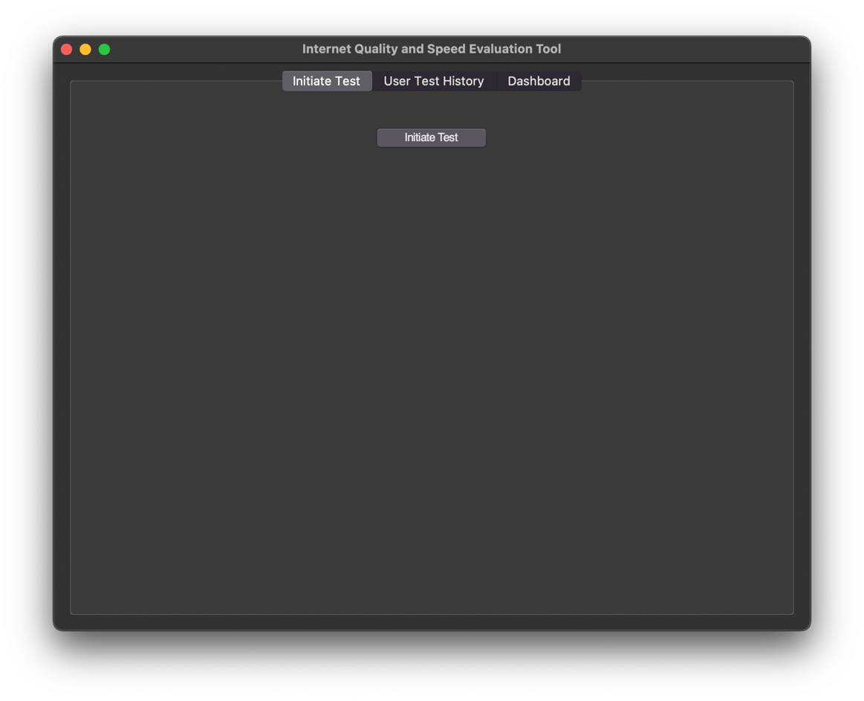

5

6

1 – Allows the user to route to the test history tab

2– This is a box that is used to hold user test history data in the according fomat. Data in this box is not stored on a data base so when the application is closed all data is gone emptying the box.

3 – The component that allows the user to import a data set of their choice must be in comma format, UTF-8 encoded and .csv format in order for the program to be able to read it .

4 – It compares the average download speed from their tests with a reference dataset if available. It then provides feedback on whether their download speed is above, below, or matches the dataset's average, along with relevant recommendations. This feature helps users gain insights into their internet performance trends and make informed decisions.

5 – ‘Initiate test’ Component upon the user clicking this it wil activate the code sequence and collect all internet statistics and display them in a pop up. It will also send this data to be temporarily stored in the user test history tab.

6 – This is the dashboard tab where users will be able to view a graphical representation of their data upon 2 different axis.

Back-End Development:

Class Definitions (diagram) and Details of Object Behaviours and Methods:

Testing Results:

Test 1:

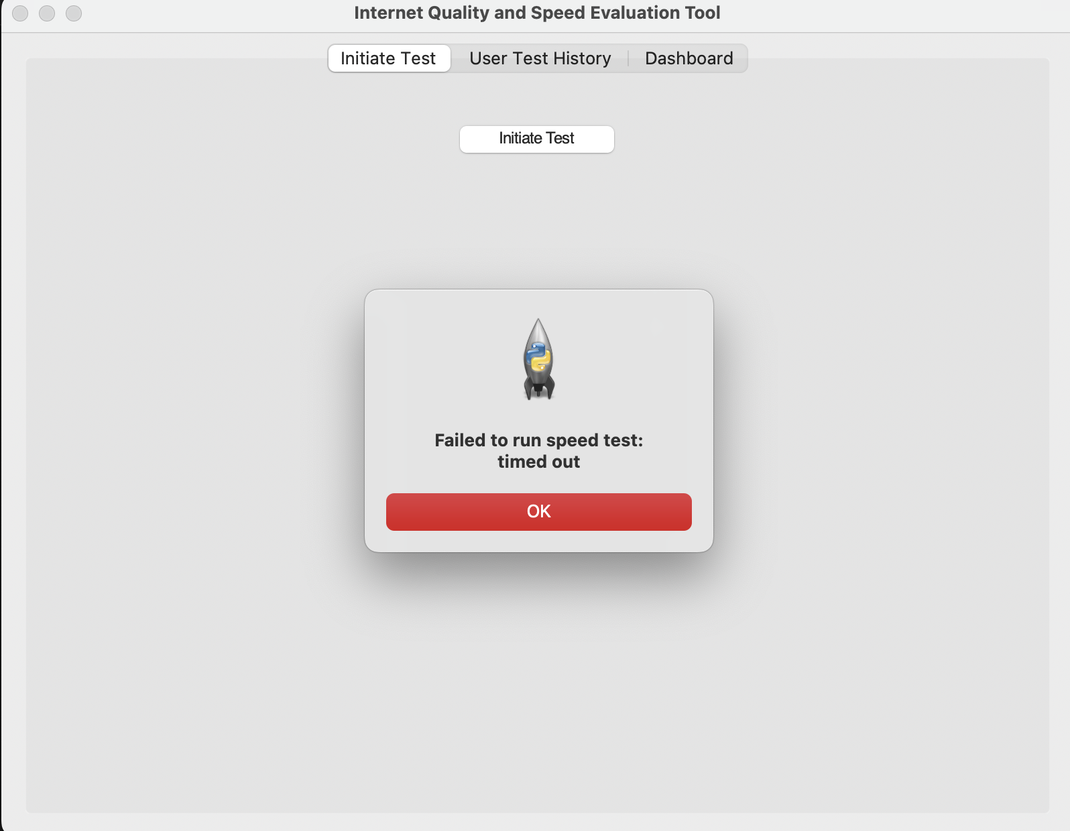

This test checks weather the user’s internet connection allows for the program to run. If the connection from the user is weak or not working, it will come up with a run time error. The user will be allowed to repeat the test again. The screenshot shows the error the end user would see if this were the case.

Test 2:

I have imported a dataset when I press analyse the expected outcome should be the download speed is below average , here we can see this is true. It scanned the dataset and compared it to the user’s data set and sent out a recommendation to the end user the screenshot shows this.

Test 3:

This test was done with the same dataset in test 2 to test whether the code would detect if the internet was above the datasets average. As you can see the dataset does show this

Test 4

The screenshot showcases a dynamic graph displaying real-time internet speed test results, offering users immediate insights into their download and upload speeds. The graph interface is visually intuitive, featuring a time-series representation of speed measurements over time.

At the horizontal axis, time intervals are delineated, indicating the progression of speed tests conducted by the user. Each increment represents a discrete moment when a speed test was initiated and completed, allowing users to track their internet speed performance across different time points.

On the vertical axis, speed measurements are depicted in megabits per second (Mbps), providing a quantitative representation of download and upload speeds. The graph illustrates fluctuations in speed, offering users a visual representation of their internet connection's stability and performance.

Test 5:

This test was run to see whether the initiate test protocol works and all the information that needed to be gathered was gathered. As you can see in the screenshot the information was pulled accurately.

Test 6:

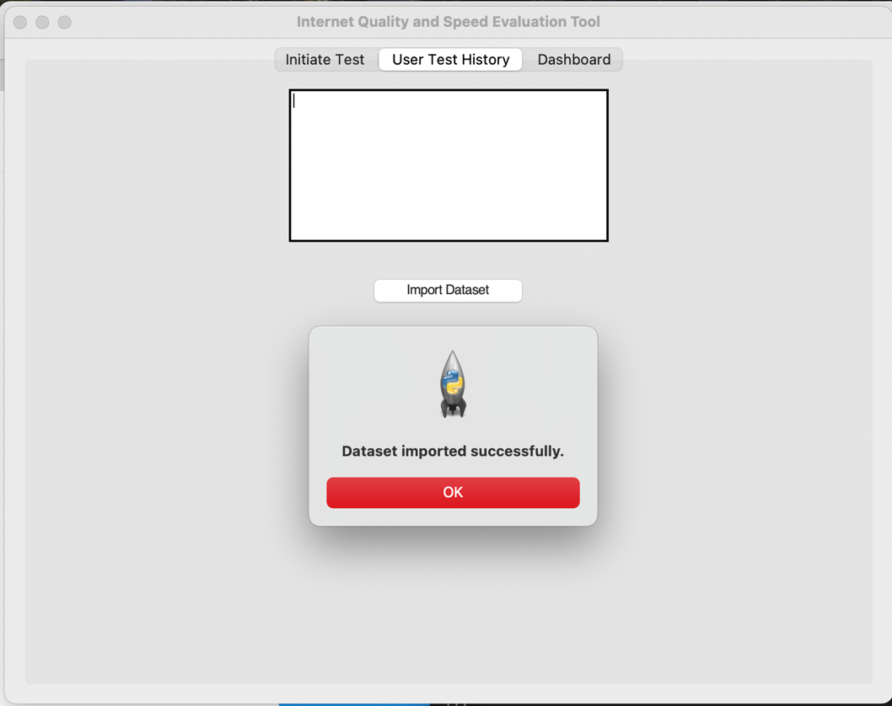

This is a test to see whether importing a dataset in the .csv format would work. As you can see by the screenshot this functionality was successful.

Test 7:

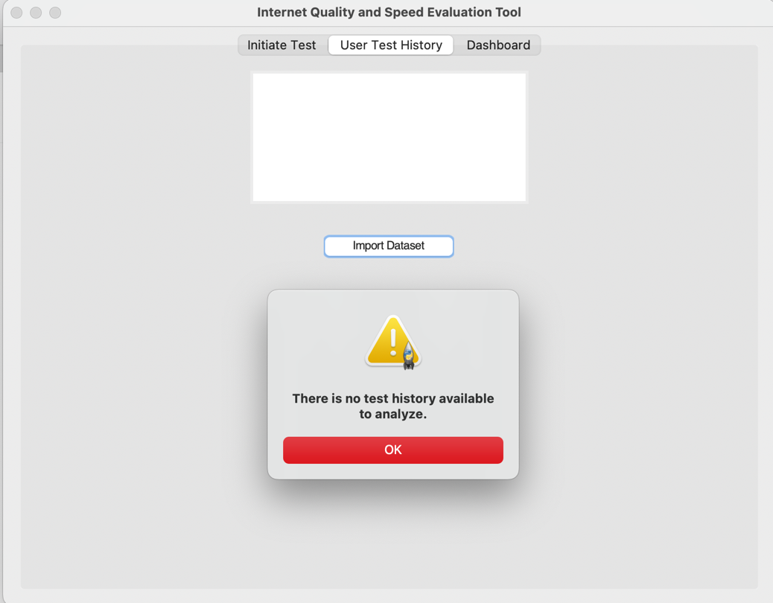

I tried to analyse history but with no test history the expected outcome should be an error. As the screenshot entails this error is successful alerting the user that there is no test history to test

Test 8:

Technical Solution Overview:

System Overview:

The system is developed using Python and leverages the tkinter library for building the graphical user interface (GUI). It facilitates internet speed testing, historical data analysis, and real-time graph visualization.

Internet Speed Testing:

Users can initiate internet speed tests, which are conducted using the Speedtest module. The application measures download speed, upload speed, ping, and jitter. Test results are displayed to the user upon completion.

Test History and Analysis:

The application maintains a history of speed test results, allowing users to track their internet performance over time. Users can also import external datasets in CSV format for comparative analysis. The system calculates average download speeds from both user-generated data and imported datasets, providing insights into the user's internet performance relative to established benchmarks.

Real-Time Graph Visualization:

The system features a dashboard tab with real-time graph visualization of download and upload speeds. Graphs dynamically update as new test results are recorded, providing users with a visual representation of their internet performance trends.

Component Structure:

The main components include the test tab for initiating speed tests, the history tab for viewing test history and importing datasets, and the dashboard tab for visualizing real-time graph data.

Threading is used to handle concurrent tasks such as running speed tests and updating the graph in real-time without blocking the main GUI thread.

User Interaction:

Users interact with the application through intuitive buttons and tabs. They can initiate speed tests, analyse historical data, import datasets, and visualize.

Class List:

InternetSpeedTool Class:

Manages the main functionalities of the application.

Handles GUI creation, tab management, and initialization of components.

SpeedTestTab Class:

Represents the tab for initiating internet speed tests.

Contains buttons and event handlers to trigger speed tests.

HistoryTab Class:

Tab responsible for displaying user test history and importing datasets.

Includes text display for historical data and buttons for importing and analyzing datasets.

DashboardTab Class:

Manages the dashboard tab for real-time graph visualization.

Utilizes Matplotlib for plotting download and upload speeds in real-time.

GraphUpdateThread Class:

Thread class for updating graphs in real-time.

Periodically retrieves new speed test results and updates the graph display.

InternetSpeedAnalyzer Class:

Handles analysis of historical data and comparison with imported datasets.

Calculates average download speeds and provides insights into internet performance.

SpeedTestHistory Class:

Stores historical internet speed test results.

Allows for retrieval and display of past test data.

**DataImport Class

This class diagram shows each of the classes involved in the program code and the procedures and functions that each can perform.

Main Code:

import tkinter as tk

from tkinter import ttk, messagebox, filedialog

import speedtest

from datetime import datetime

from matplotlib.figure import Figure

from matplotlib.backends.backend_tkagg import FigureCanvasTkAgg

import pandas as pd

import threading

import time

class InternetSpeedTool:

def __init__(self, root):

self.root = root

self.root.title("Internet Quality and Speed Evaluation Tool")

# Styling

style = ttk.Style()

style.configure("TButton", padding=10, font=('Helvetica', 12))

# Create a notebook (tabbed interface)

self.notebook = ttk.Notebook(root)

self.notebook.pack(expand=True, fill='both')

# Test history

self.test_history = []

# Imported dataset

self.imported_dataset = pd.DataFrame() # Initialize an empty DataFrame

# Create tabs

self.create_test_tab()

self.create_history_tab()

self.create_dashboard_tab()

# Initialize variables for real-time graph

self.plot_thread = None

def create_test_tab(self):

test_tab = ttk.Frame(self.notebook)

self.notebook.add(test_tab, text='Initiate Test')

# Add components to the test tab

initiate_test_button = ttk.Button(test_tab, text='Initiate Test', command=self.initiate_test)

initiate_test_button.pack(pady=20)

def create_history_tab(self):

history_tab = ttk.Frame(self.notebook)

self.notebook.add(history_tab, text='User Test History')

# Add components to the history tab

self.history_text = tk.Text(history_tab, wrap=tk.WORD, width=40, height=10)

self.history_text.pack(padx=10, pady=10)

# Import button

import_button = ttk.Button(history_tab, text='Import Dataset', command=self.import_dataset)

import_button.pack(pady=10)

# Analyze button

analyze_button = ttk.Button(history_tab, text='Analyze History', command=self.analyze_test_history)

analyze_button.pack(pady=10)

def create_dashboard_tab(self):

dashboard_tab = ttk.Frame(self.notebook)

self.notebook.add(dashboard_tab, text='Dashboard')

# Add components to the dashboard tab

self.fig = Figure(figsize=(6, 10), dpi=100) # Adjust the figure size for multiple subplots

self.ax1 = self.fig.add_subplot(211) # First subplot

self.ax1.set_xlabel('Time')

self.ax1.set_ylabel('Download Speed (Mbps)')

self.ax2 = self.fig.add_subplot(212) # Second subplot

self.ax2.set_xlabel('Time')

self.ax2.set_ylabel('Upload Speed (Mbps)')

self.graph = FigureCanvasTkAgg(self.fig, master=dashboard_tab)

self.graph.get_tk_widget().pack(side=tk.TOP, fill=tk.BOTH, expand=True)

def initiate_test(self):

# Start the test in a separate thread

test_thread = threading.Thread(target=self.run_speed_test)

test_thread.start()

def run_speed_test(self):

try:

st = speedtest.Speedtest()

st.get_best_server()

download_speed = st.download() / 1_000_000 # Convert to Mbps

upload_speed = st.upload() / 1_000_000 # Convert to Mbps

ping = st.results.ping

# Display test results

messagebox.showinfo("Test Results",

f"Download Speed: {download_speed:.2f} Mbps\n"

f"Upload Speed: {upload_speed:.2f} Mbps\n"

f"Ping: {ping} ms")

test_result = {

"timestamp": datetime.now().strftime("%Y-%m-%d %H:%M:%S"),

"download_speed": download_speed,

"upload_speed": upload_speed,

"ping": ping

}

self.test_history.append(test_result)

self.update_history_tab()

self.update_graph() # Update the graph after each test

except Exception as e:

messagebox.showerror("Test Error", f"Failed to run speed test: {str(e)}")

def import_dataset(self):

# Allow users to import a dataset in CSV format

file_path = filedialog.askopenfilename(filetypes=[("CSV files", "*.csv")])

if file_path:

try:

self.imported_dataset = pd.read_csv(file_path)

messagebox.showinfo("Dataset Imported", "Dataset imported successfully.")

except Exception as e:

messagebox.showerror("Import Error", f"Failed to import dataset: {str(e)}")

def analyze_test_history(self):

if not self.imported_dataset.empty: # Check if the DataFrame is empty

# Calculate average download speed from the dataset

avg_download_dataset = self.imported_dataset['download_speed'].mean()

if self.test_history:

# Calculate average download speed from user's test history

avg_download_user = sum(result['download_speed'] for result in self.test_history) / len(self.test_history)

# Compare the user's average download speed with the dataset's average

comparison_result = "Comparison Result:\n"

if avg_download_user > avg_download_dataset:

comparison_result += "Your average download speed is above the dataset's average.\n"

# Provide recommendations for above average performance

comparison_result += "You are experiencing good internet performance. Keep up the good work!"

elif avg_download_user < avg_download_dataset:

comparison_result += "Your average download speed is below the dataset's average.\n"

# Provide recommendations for below average performance

comparison_result += "You may want to consider contacting your internet service provider for assistance."

else:

comparison_result += "Your average download speed matches the dataset's average.\n"

# Provide neutral recommendations

comparison_result += "Your internet performance is consistent with the dataset."

# Display analysis result

messagebox.showinfo("History Analysis", comparison_result)

else:

messagebox.showwarning("No Test History", "There is no test history available to analyze.")

else:

messagebox.showerror("Dataset Error", "The imported dataset is empty.")

def update_history_tab(self):

# Display test history in the history tab

self.history_text.delete(1.0, tk.END)

for result in self.test_history:

self.history_text.insert(tk.END, f"Timestamp: {result['timestamp']}\n")

self.history_text.insert(tk.END, f"Download Speed: {result['download_speed']:.2f} Mbps\n")

self.history_text.insert(tk.END, f"Upload Speed: {result['upload_speed']:.2f} Mbps\n")

self.history_text.insert(tk.END, f"Ping: {result['ping']} ms\n\n")

def update_graph(self):

if self.test_history: # Check if there are test results

download_speeds = [result['download_speed'] for result in self.test_history]

upload_speeds = [result['upload_speed'] for result in self.test_history]

self.ax1.clear()

self.ax1.plot(range(len(download_speeds)), download_speeds, label='Download Speed')

self.ax1.legend()

self.ax2.clear()

self.ax2.plot(range(len(upload_speeds)), upload_speeds, label='Upload Speed')

self.ax2.legend()

self.graph.draw()

def start_plot_thread(self):

# Start the thread for real-time graph updates

self.plot_thread = threading.Thread(target=self.update_graph)

self.plot_thread.daemon = True

self.plot_thread.start()

if __name__ == "__main__":

root = tk.Tk()

app = InternetSpeedTool(root)

root.geometry("800x600") # Set a custom window size

app.start_plot_thread() # Start the real-time graph update thread

root.mainloop()

Appraisal

The dynamic speed test project effectively addresses the outlined objectives, demonstrating a comprehensive understanding of network speed evaluation and implementation across various metrics. Below is an assessment of the project's performance against each objective:

Objective 1: User Interface and Speed Test Initiation

1.1 Allow users to initiate speed tests: The project meets this objective by providing a user interface where users can initiate speed tests with the click of a button.

1.2 User-friendly interface: The user interface is intuitive and straightforward, allowing users to initiate tests easily and view results without confusion.

Objective 2: Real-Time Speed Measurement

2.1 Real-time download speed measurement: The project successfully measures and displays real-time download speeds, providing users with accurate and up-to-date information about their network performance.

2.2 Real-time upload speed measurement: Similarly, the project effectively measures and displays real-time upload speeds, enabling users to assess both download and upload performance.

Objective 3: Test History and Analysis

3.1 Maintain a test history: The project maintains a comprehensive test history, allowing users to review past speed test results and track changes in network performance over time.

3.2 User-friendly test history display: The test history display is clear and organized, presenting test results in a readable format for easy analysis.

Objective 4: Dashboard Visualization

4.1 Graphical representation of speed test results: The project includes graphical visualization of speed test results, enhancing user experience by providing visual insights into network performance trends.

4.2 Dynamic graph updates: Graphs dynamically update to reflect the latest test results, ensuring that users always have access to the most current network performance data.

Objective 5: Error Handling and Reliability

5.1 Error handling mechanisms: The project incorporates robust error handling mechanisms, ensuring reliable performance even in challenging network conditions or unexpected scenarios.

5.2 Reliability of speed measurements: Speed measurements are reliable and accurate, providing users with confidence in the integrity of the test results.

Feedback:

User Feedback

I have gathered feedback from both Mr. R and a group of students who are currently engaged in the evaluation of the new A Level Specification.

Mr. R (discussion):

Mr. R expressed satisfaction in observing that I successfully integrated all the core functionalities we had discussed for the dynamic internet speed test project. He particularly appreciated the inclusion of TCP/IP, which was initially an extension idea for the project.

Regarding the functionality of the speed test, Mr. R commended the clarity of the user interface. He appreciated how users can easily initiate speed tests and interpret the results displayed. He found the graphical representation of upload and download speeds intuitive and informative.

Mr. R also provided constructive feedback on potential improvements. He suggested enhancing the interface by including additional information during the speed test process, such as real-time latency measurements and server ping times. He believed that these additions could further enrich the user experience and provide more comprehensive insights into network performance.

Analysis of Feedback:

Mr. R expressed overall satisfaction with the performance and usability of the dynamic internet speed test. His suggestions for interface enhancements align well with the project's objectives of providing users with detailed insights into their internet connection performance.

Student Feedback (questionnaire):

The questionnaires collected from students provided valuable insights into their experience with the dynamic internet speed test project.

Overall, students expressed positive feedback regarding the usability and effectiveness of the speed test application. They found the interface intuitive and easy to navigate, allowing them to initiate speed tests with minimal effort.

Several students highlighted the importance of visual representations in understanding internet speed metrics. They appreciated the graphical display of upload and download speeds, which facilitated quick comprehension of network performance.

However, some students suggested potential areas for improvement. They expressed interest in additional features, such as historical performance tracking and comparative analysis tools. They believed that these features could enhance the utility of the speed test application and provide users with deeper insights into their internet connectivity over time.

Analysis of Feedback:

The student feedback underscores the success of the dynamic internet speed test project in meeting user expectations for simplicity and functionality. Their suggestions for future enhancements reflect a desire for advanced features that could further enrich the user experience and provide more comprehensive network performance insights.

In conclusion, the feedback received from both Mr. R and the student group reaffirms the project's success in delivering a user-friendly and informative internet speed test application. Moving forward, incorporating suggested enhancements will be instrumental in further improving the application's utility and user satisfaction.

Possible Extensions:

1. Enhanced Result Display:

Consider incorporating additional information in the result display, such as real-time latency measurements and server ping times. This would provide users with a more comprehensive understanding of their internet connection performance.

2. Historical Performance Tracking:

Explore the possibility of adding a feature for historical performance tracking. Users could benefit from the ability to view and analyse their internet speed trends over time, allowing for a more thorough assessment of their connection stability.

3. Comparative Analysis Tools:

Integrate tools for comparative analysis, enabling users to compare their current speed test results with previous ones. This feature could contribute to a better understanding of fluctuations in internet speed and assist users in identifying patterns.

4. User-Defined Testing Parameters:

Provide users with the option to customize testing parameters, allowing them to specify aspects of the speed test, such as the duration or the selection of specific servers for testing. This customization could enhance the flexibility and relevance of the speed test.

5. Interactive User Guide:

Develop an interactive user guide within the application. This guide could offer step-by-step instructions on utilizing the various features of the speed test, ensuring that users have quick access to information that can help them make the most of the application.

6. User-Requested Feature Implementation:

Consider implementing features suggested by users in the feedback, such as additional insights into network performance or specific functionalities that users find valuable. User-requested features can enhance the application's user-centric design.

7. Manual Connection Management:

Implement a feature that allows users to manually manage TCP/IP connections. This would provide users with greater control over their connections, allowing them to initiate or terminate connections as needed, without having to shut down the entire program.

8. Efficient Message Handling:

Enhance the message handling system to allow users to view all received data from a TCP/IP connection. This improvement would enable users to revisit and utilize messages they chose not to use initially, providing a more efficient and flexible user experience.

9. Streamlined File Transfer:

Implement user-friendly buttons on forms for sending and receiving messages and files over a TCP/IP connection. This enhancement would streamline the process, making it quicker and more accessible for users to exchange information within the application.

10. Clearer Interface Labels:

- Consider adding labels or additional information to the interface elements to make it clearer and more user-friendly. This could include tooltips, pop-up explanations, or inline text to guide users through the functionalities of the dynamic internet speed test application.

Conclusion

In conclusion, these possible extensions aim to build upon the success of the dynamic internet speed test project, offering users additional features and improvements based on feedback and potential areas for enhancement. These extensions are feasible and align with the project's goal of providing a valuable tool for evaluating and understanding internet speed.